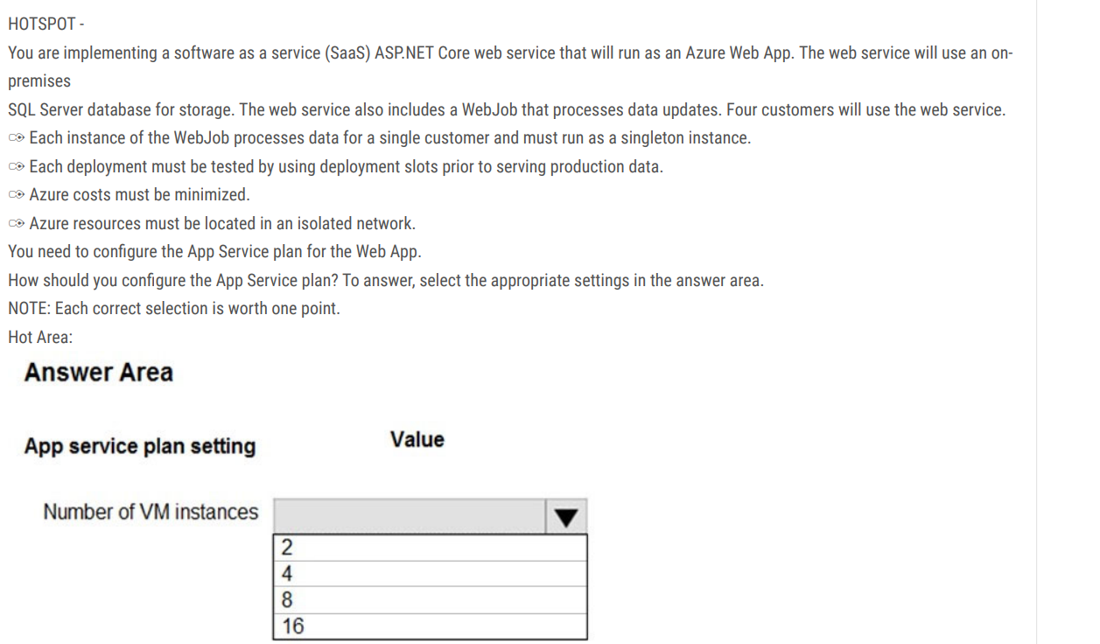

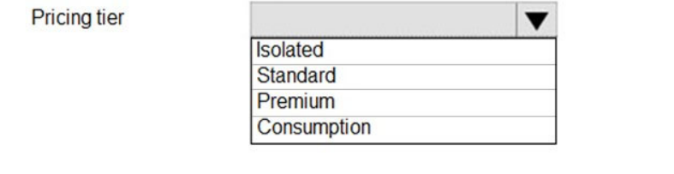

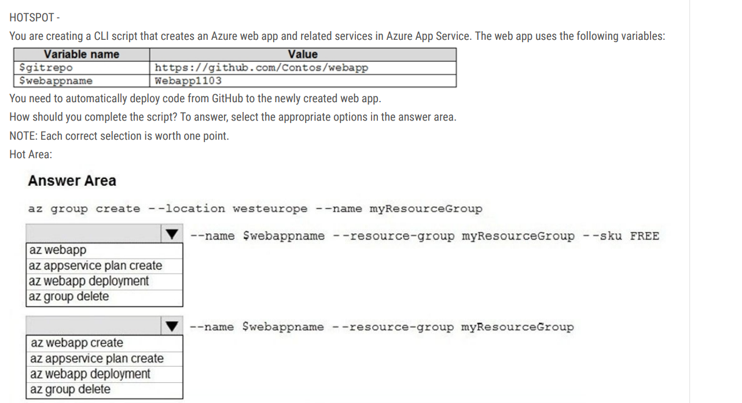



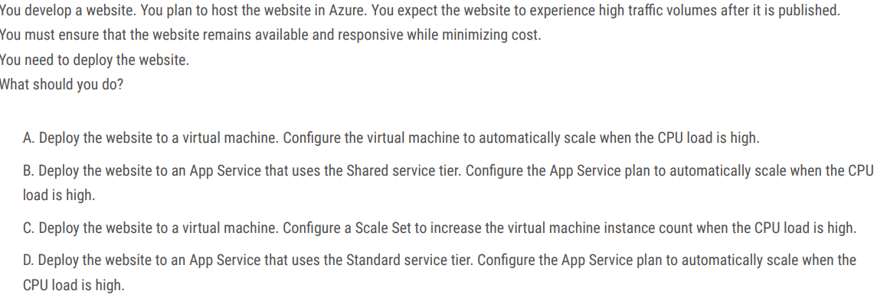



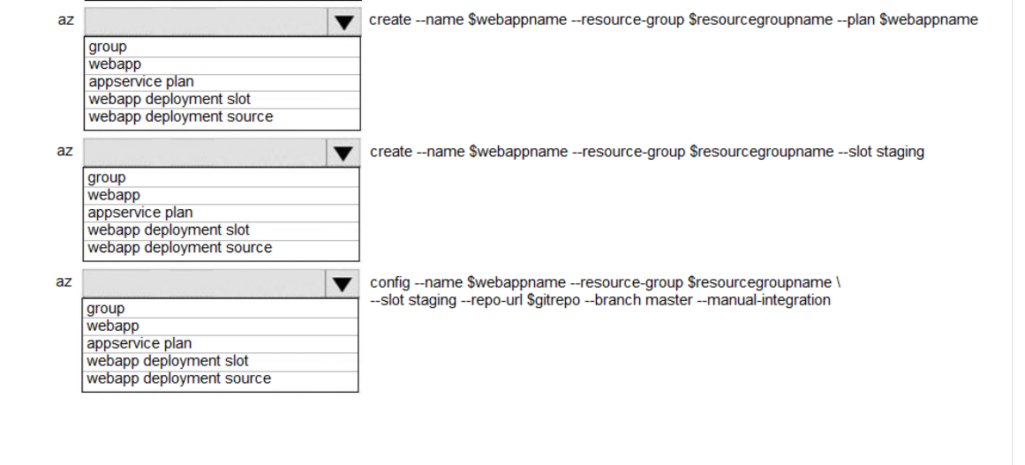You are developing an Azure Function App that processes images that are uploaded to an Azure Blob container. Images must be processed as quickly as possible after they are uploaded, and the solution must minimize latency. You create code to process images when the Function App is triggered.

You need to configure the Function App.

What should you do?

A. Use an App Service plan. Configure the Function App to use an Azure Blob Storage input trigger.

B. Use a Consumption plan. Configure the Function App to use an Azure Blob Storage trigger.

C. Use a Consumption plan. Configure the Function App to use a Timer trigger.

D. Use an App Service plan. Configure the Function App to use an Azure Blob Storage trigger.

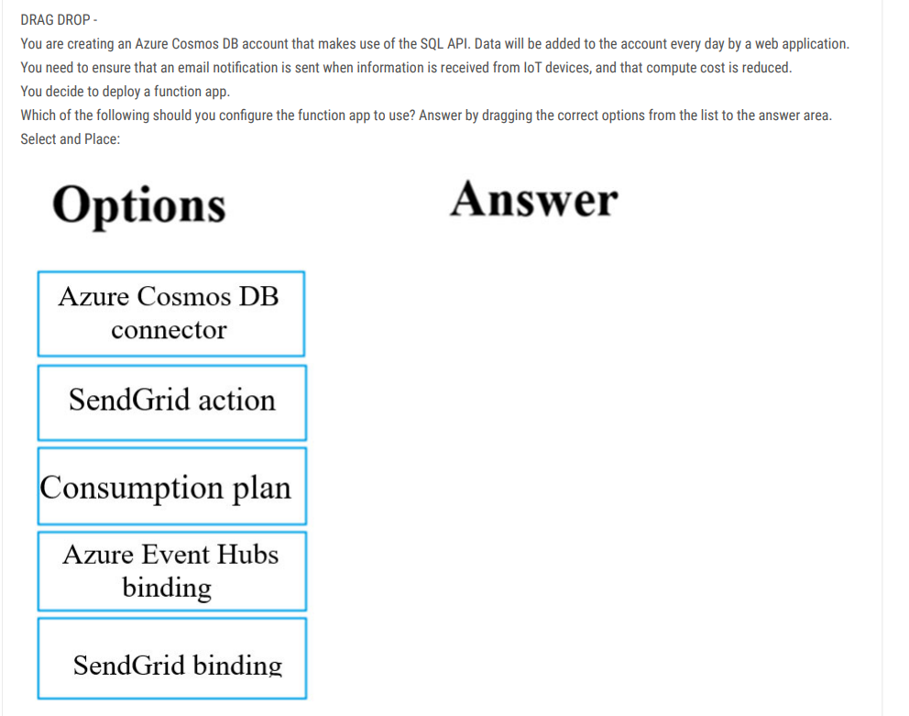

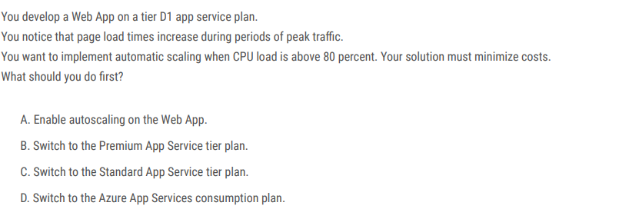

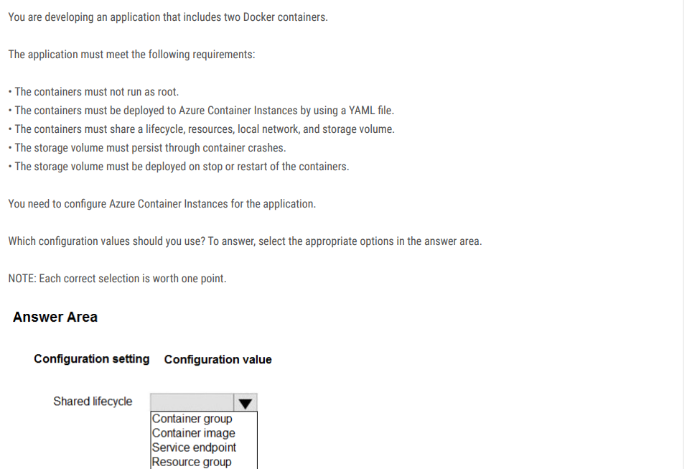

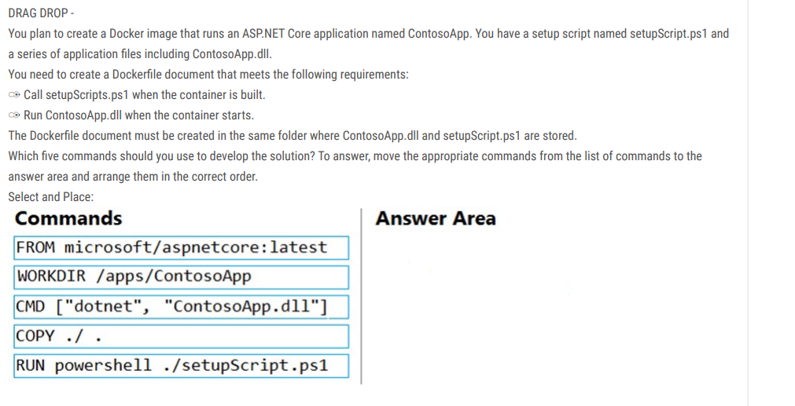

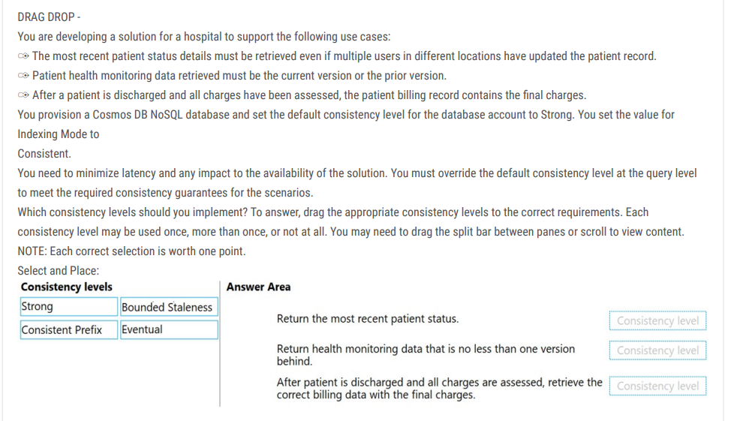



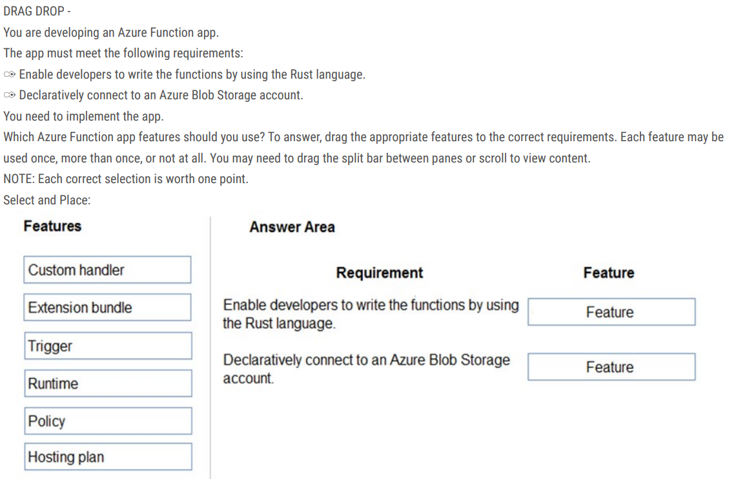

You have two Hyper-V hosts named Host1 and Host2. Host1 has an Azure virtual machine named VM1 that was deployed by using a custom Azure Resource Manager template. You need to move VM1 to Host2. What should you do?

A. From the Update management blade, click Enable.

B. From the Overview blade, move VM1 to a different subscription.

C. From the Redeploy blade, click Redeploy.

D. From the Profile blade, modify the usage location.

When you redeploy a VM, it moves the VM to a new node within the Azure infrastructure and then powers it back on, retaining all your configuration options and associated resources.

Reference:

<https://docs.microsoft.com/en-us/azure/virtual-machines/windows/redeploy-to-new-node>

DRAG DROP - You have downloaded an Azure Resource Manager template to deploy numerous virtual machines. The template is based on a current virtual machine, but must be adapted to reference an administrative password. You need to make sure that the password is not stored in plain text. You are preparing to create the necessary components to achieve your goal. Which of the following should you create to achieve your goal? Answer by dragging the correct option from the list to the answer area. Select and Place:

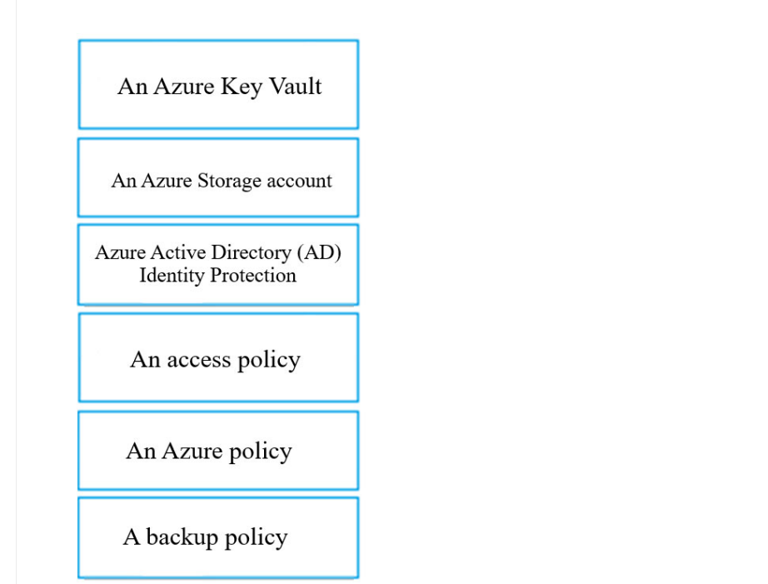

Your company has an Azure subscription. You need to deploy a number of Azure virtual machines to the subscription by using Azure Resource Manager (ARM) templates. The virtual machines will be included in a single availability set. You need to ensure that the ARM template allows for as many virtual machines as possible to remain accessible in the event of fabric failure or maintenance. Which of the following is the value that you should configure for the platformFaultDomainCount property? A. 10

B. 30

C. Min Value

D. Max Value

Correct Answer: D

The number of fault domains for managed availability sets varies by region - either two or three per region.

Reference: <https://docs.microsoft.com/en-us/azure/virtual-machines/windows/manage-availability>

You are developing an e-Commerce Web App. You want to use Azure Key Vault to ensure that sign-ins to the e-Commerce Web App are secured by using Azure App Service authentication and Azure Active Directory (AAD). What should you do on the e-Commerce Web App?

A. Run the az keyvault secret command.

B. Enable Azure AD Connect.

C. Enable Managed Service Identity (MSI).

D. Create an Azure AD service principal.

Correct Answer: C

A managed identity from Azure Active Directory allows your app to easily access other AAD-protected resources such as Azure Key Vault.

Reference:

https://docs.microsoft.com/en-us/azure/app-service/overview-managed-identity https://docs.microsoft.com/en-us/samples/azuresamples/app-service-msi-keyvault-dotnet/keyvault-msi-appservice-sample/

You are creating an Azure key vault using PowerShell. Objects deleted from the key vault must be kept for a set period of 90 days. Which two of the following parameters must be used in conjunction to meet the requirement? (Choose two.)

A. EnabledForDeployment

B. EnablePurgeProtection

C. EnabledForTemplateDeployment

D. EnableSoftDelete

Correct Answer: BD

Reference:

https://docs.microsoft.com/en-us/powershell/module/azurerm.keyvault/new-azurermkeyvault https://docs.microsoft.com/en-us/azure/keyvault/key-vault-ovw-soft-delete

You are developing an application to transfer data between on-premises file servers and Azure Blob storage. The application stores keys, secrets, and certificates in Azure Key Vault and makes use of the Azure Key Vault APIs. You want to configure the application to allow recovery of an accidental deletion of the key vault or key vault objects for 90 days after deletion. What should you do?

A. Run the Add-AzKeyVaultKey cmdlet.

B. Run the az keyvault update --enable-soft-delete true --enable-purge-protection true CLI.

C. Implement virtual network service endpoints for Azure Key Vault.

D. Run the az keyvault update --enable-soft-delete false CLI.

Correct Answer: B

When soft-delete is enabled, resources marked as deleted resources are retained for a specified period (90 days by default). The service further provides a mechanism for recovering the deleted object, essentially undoing the deletion. Purge protection is an optional Key Vault behavior and is not enabled by default. Purge protection can only be enabled once soft-delete is enabled. When purge protection is on, a vault or an object in the deleted state cannot be purged until the retention period has passed. Soft-deleted vaults and objects can still be recovered, ensuring that the retention policy will be followed. The default retention period is 90 days, but it is possible to set the retention policy interval to a value from 7 to 90 days through the Azure portal. Once the retention policy interval is set and saved it cannot be changed for that vault.

Reference: <https://docs.microsoft.com/en-us/azure/key-vault/general/overview-soft-delete>

You are developing a .NET Core MVC application that allows customers to research independent holiday accommodation providers. You want to implement Azure Search to allow the application to search the index by using various criteria to locate documents related to accommodation. You want the application to allow customers to search the index by using regular expressions. What should you do?

A. Configure the SearchMode property of the SearchParameters class.

B. Configure the QueryType property of the SearchParameters class.

C. Configure the Facets property of the SearchParameters class.

D. Configure the Filter property of the SearchParameters class.

Correct Answer: B

The SearchParameters.QueryType Property gets or sets a value that specifies the syntax of the search query. The default is 'simple'. Use 'full' if your query uses the Lucene query syntax. You can write queries against Azure Search based on the rich Lucene Query Parser syntax for specialized query forms: wildcard, fuzzy search, proximity search, regular expressions are a few examples.

Reference:

https://docs.microsoft.com/en-us/dotnet/api/microsoft.azure.search.models.searchparameters https://docs.microsoft.com/enus/dotnet/api/microsoft.azure.search.models.searchparameters.querytype

You are developing a .NET Core MVC application that allows customers to research independent holiday accommodation providers. You want to implement Azure Search to allow the application to search the index by using various criteria to locate documents related to accommodation venues. You want the application to list holiday accommodation venues that fall within a specific price range and are within a specified distance to an airport. What should you do?

A. Configure the SearchMode property of the SearchParameters class.

B. Configure the QueryType property of the SearchParameters class.

C. Configure the Facets property of the SearchParameters class.

D. Configure the Filter property of the SearchParameters class.

Correct Answer: D

The Filter property gets or sets the OData $filter expression to apply to the search query.

Reference:

https://docs.microsoft.com/en-us/dotnet/api/microsoft.azure.search.models.searchparameters https://docs.microsoft.com/enus/dotnet/api/microsoft.azure.search.models.searchparameters.querytype

You are authoring a set of nested Azure Resource Manager templates to deploy Azure resources. You author an Azure Resource Manager template named mainTemplate.json that contains the following linked templates: linkedTemplate1.json, linkedTemplate2.json.

You add parameters to a parameters template file named mainTemplate.parameters,json. You save all templates on a local device in the C:\templates\ folder.

You have the following requirements:

• Store the templates in Azure for later deployment.

• Enable versioning of the templates.

• Manage access to the templates by using Azure RBAC.

• Ensure that users have read-only access to the templates.

• Allow users to deploy the templates.

You need to store the templates in Azure. How should you complete the command? To answer, select the appropriate options in the answer area.

NOTE: Each correct selection is worth one point

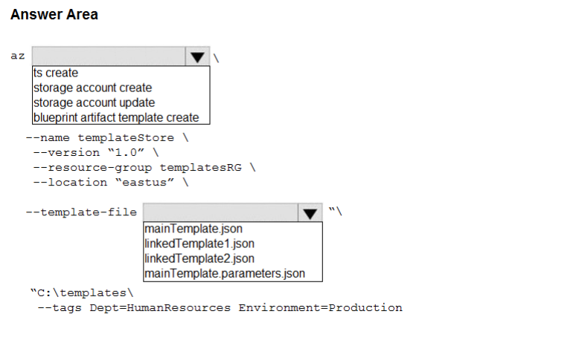

DRAG DROP –

You are a developer for a software as a service (SaaS) company that uses an Azure Function to process orders. The Azure Function currently runs on an Azure Function app that is triggered by an Azure Storage queue. You are preparing to migrate the Azure Function to Kubernetes using Kubernetes-based Event Driven Autoscaling (KEDA). You need to configure Kubernetes Custom Resource Definitions (CRD) for the Azure Function. Which CRDs should you configure?

To answer, drag the appropriate CRD types to the correct locations. Each CRD type may be used once, more than once, or not at all. You may need to drag the split bar between panes or scroll to view content.

NOTE: Each correct selection is worth one point. Select and Place

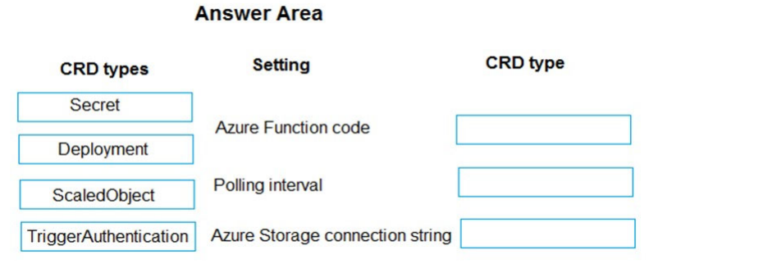

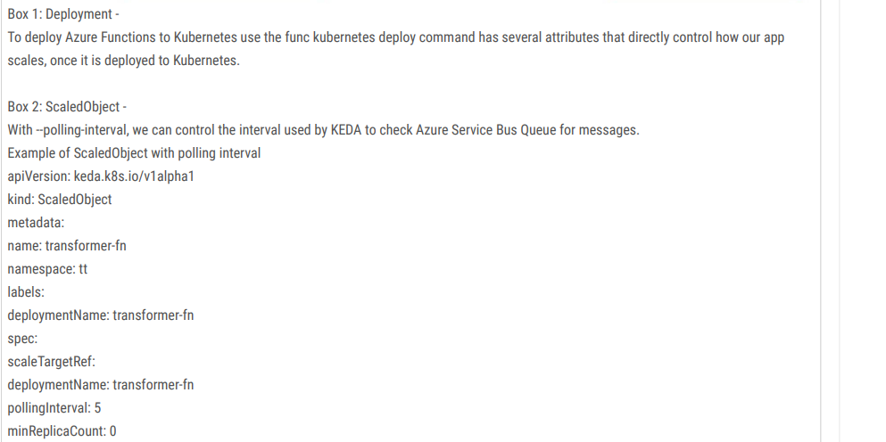

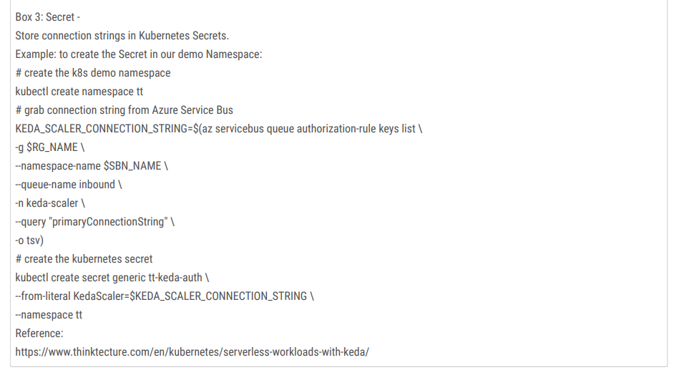

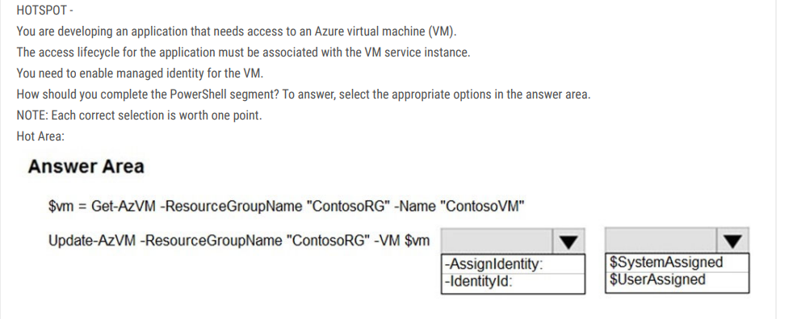

Box 1: -IdentityType - Enable system-assigned managed identity on an existing Azure VM: To enable a system-assigned managed identity, use the -IdentityType switch on the Update-AzVM cmdlet (see below).

Box 2: $SystemAssigned - $vm = Get-AzVM -ResourceGroupName myResourceGroup -Name myVM Update-AzVM -ResourceGroupName myResourceGroup -VM $vm -IdentityType SystemAssigned

Reference:

<https://docs.microsoft.com/en-us/azure/active-directory/managed-identities-azure-resources/qs-configure-powershell-windows-vm>

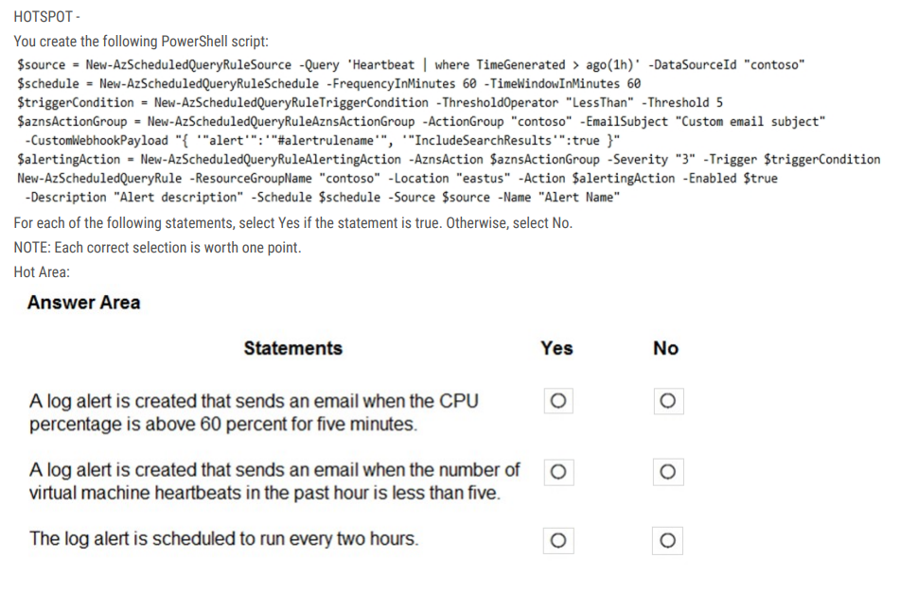

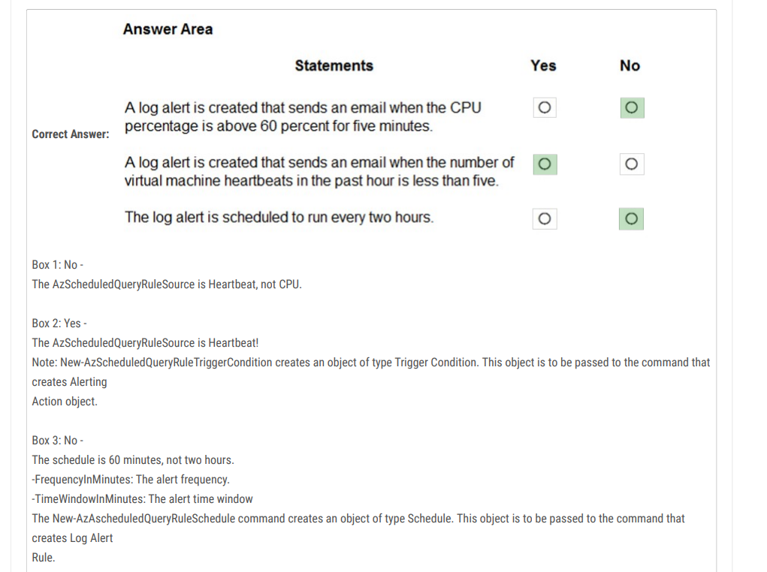

Reference:

https://docs.microsoft.com/en-us/powershell/module/az.monitor/new-azscheduledqueryrule https://docs.microsoft.com/enus/powershell/module/az.monitor/new-azscheduledqueryruletriggercondition

HOTSPOT –

You are developing a back-end Azure App Service that scales based on the number of messages contained in a Service Bus queue.

A rule already exists to scale up the App Service when the average queue length of unprocessed and valid queue messages is greater than 1000.

You need to add a new rule that will continuously scale down the App Service as long as the scale up condition is not met. How should you configure the Scale rule?

To answer, select the appropriate options in the answer area.

NOTE: Each correct selection is worth one point. Hot Area

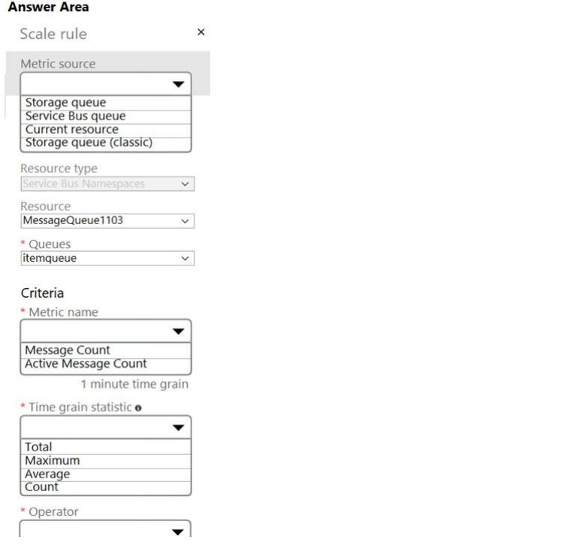

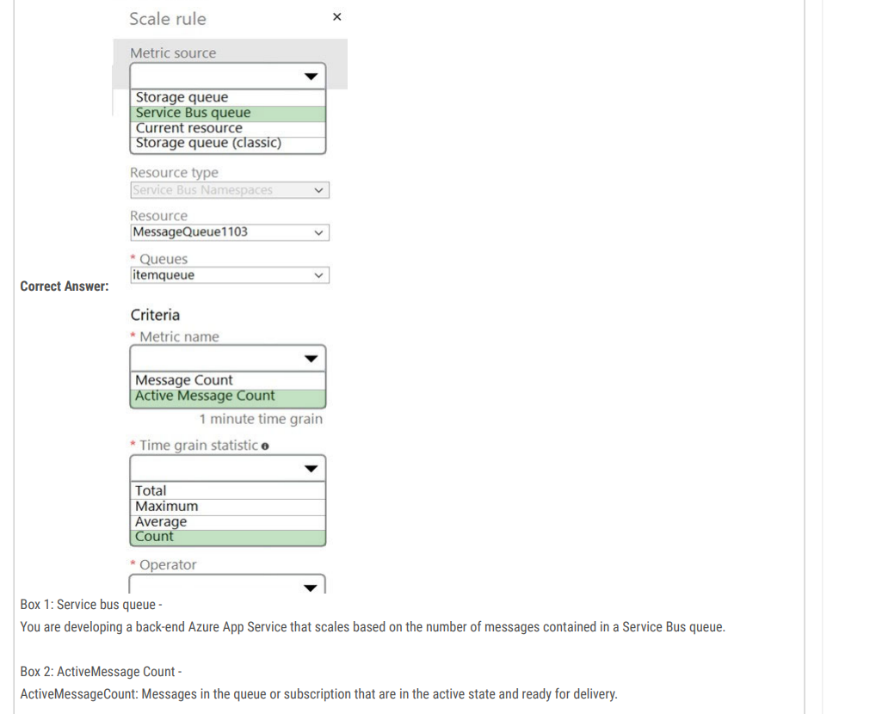

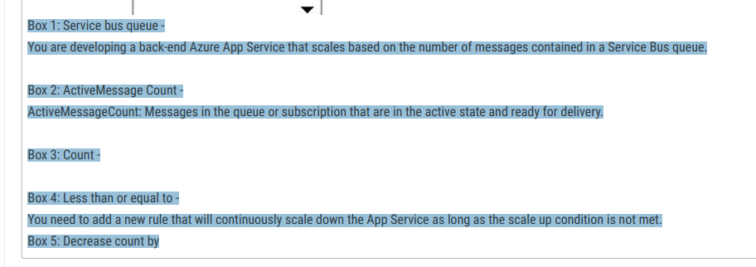

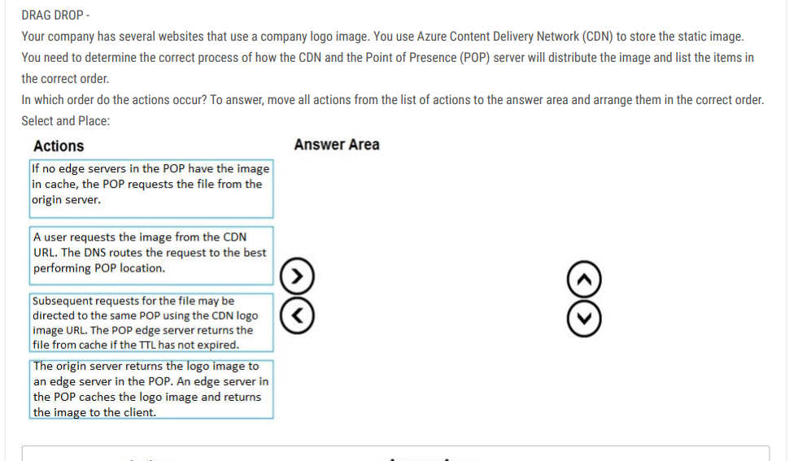

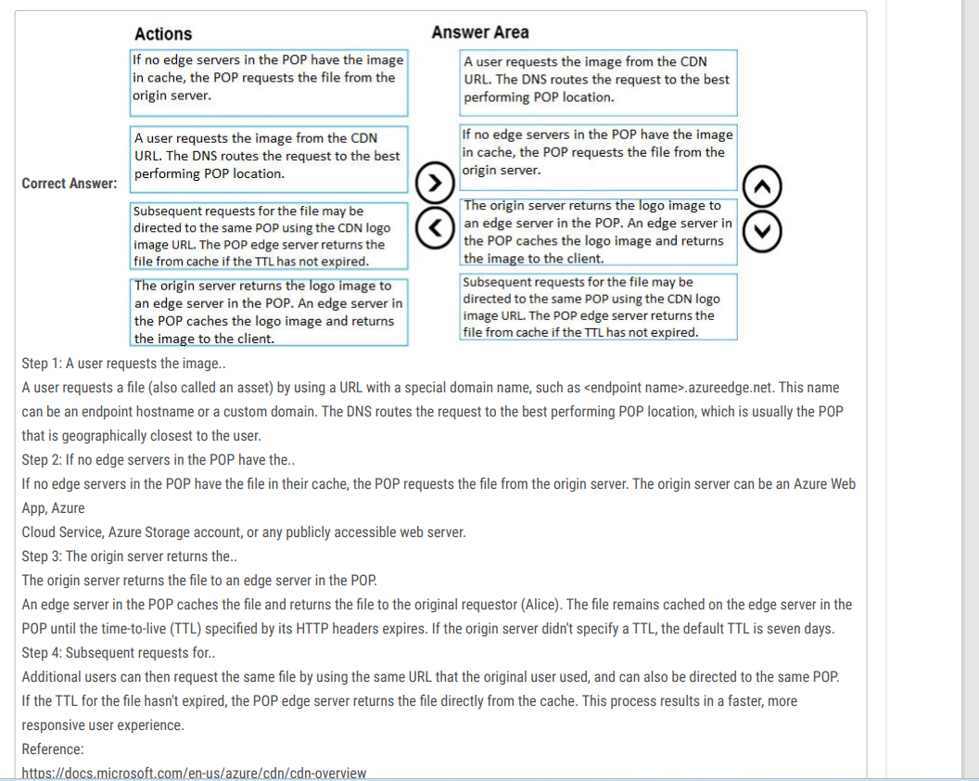

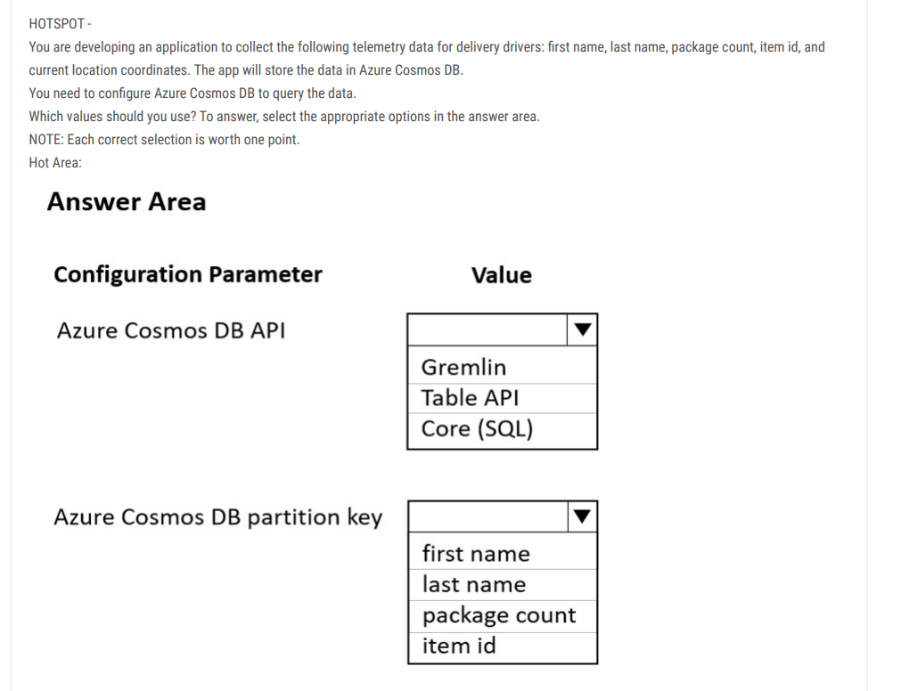

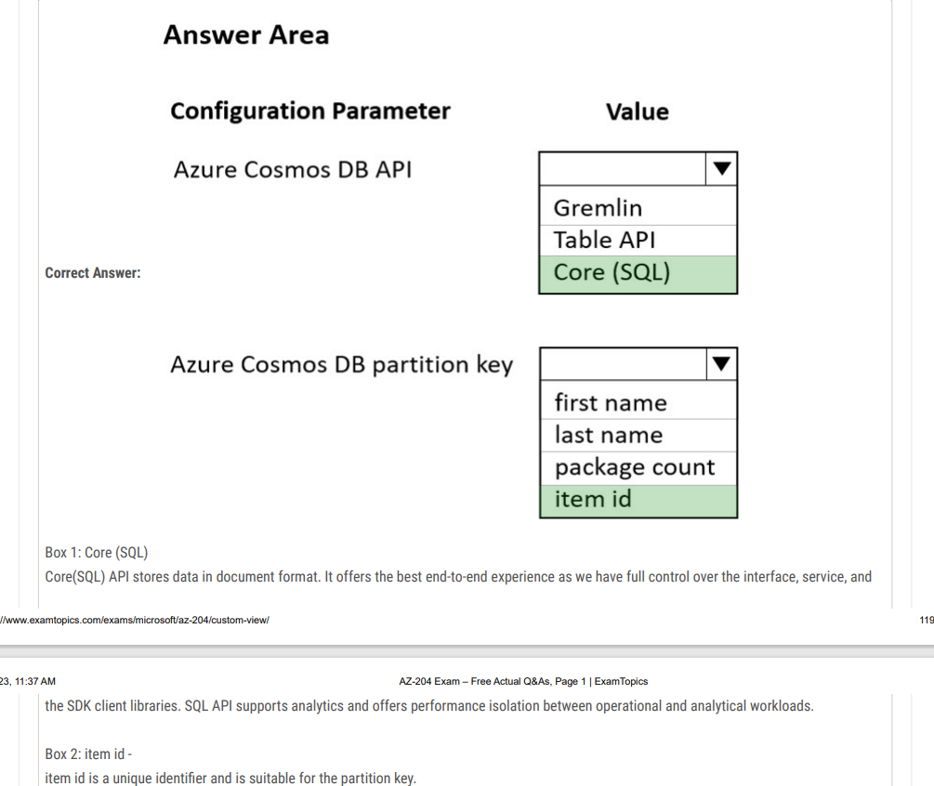

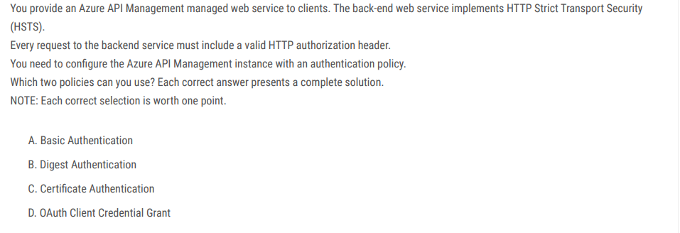

Correct Answer: CD

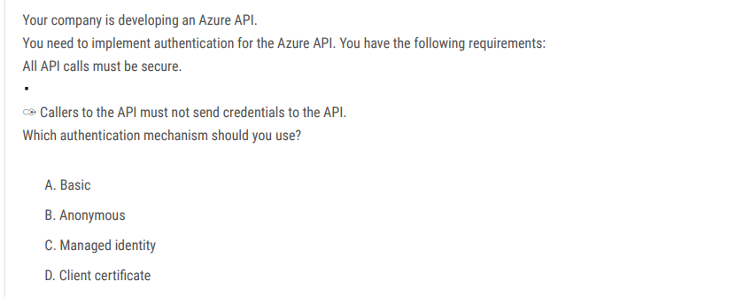

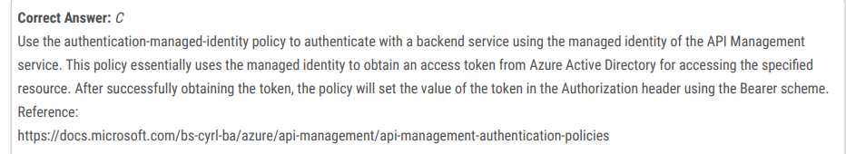

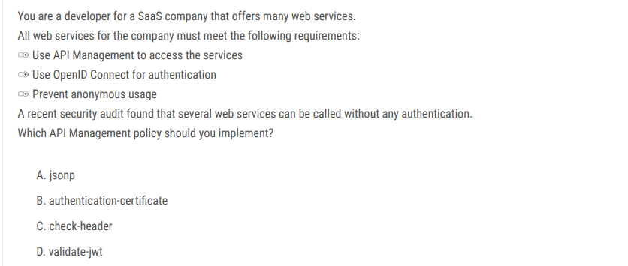

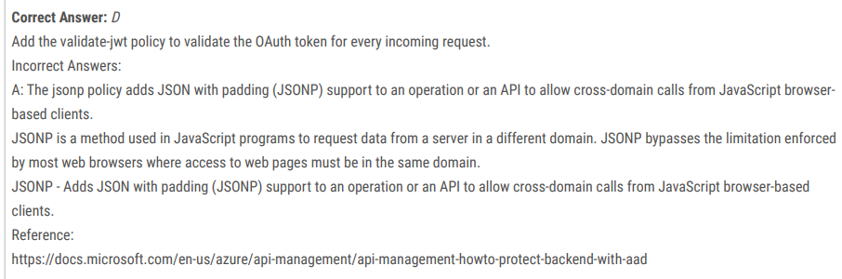

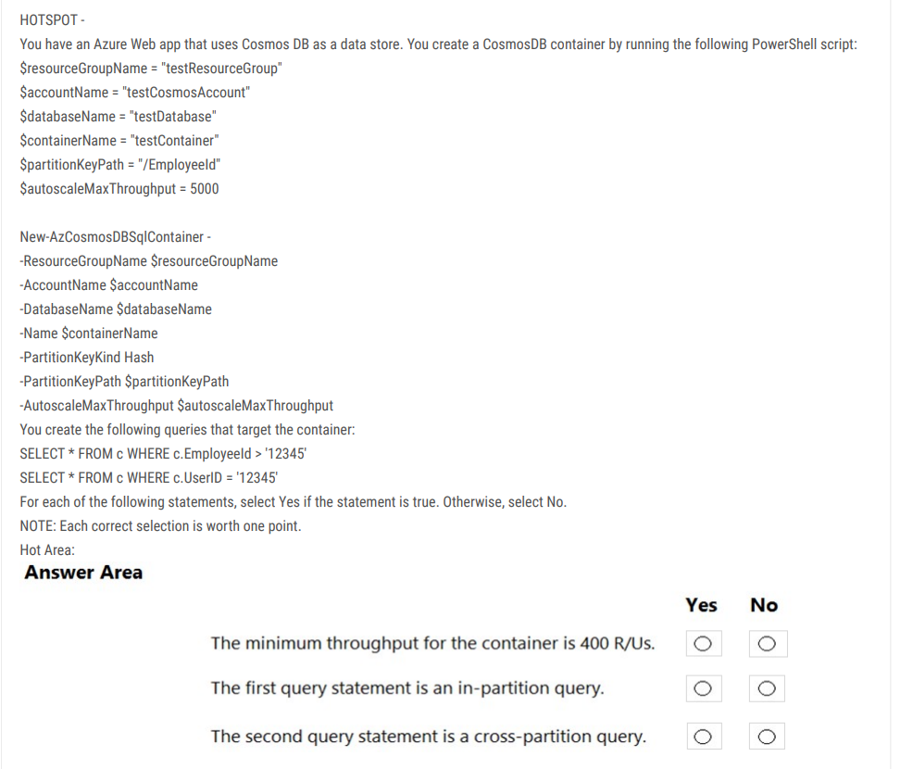

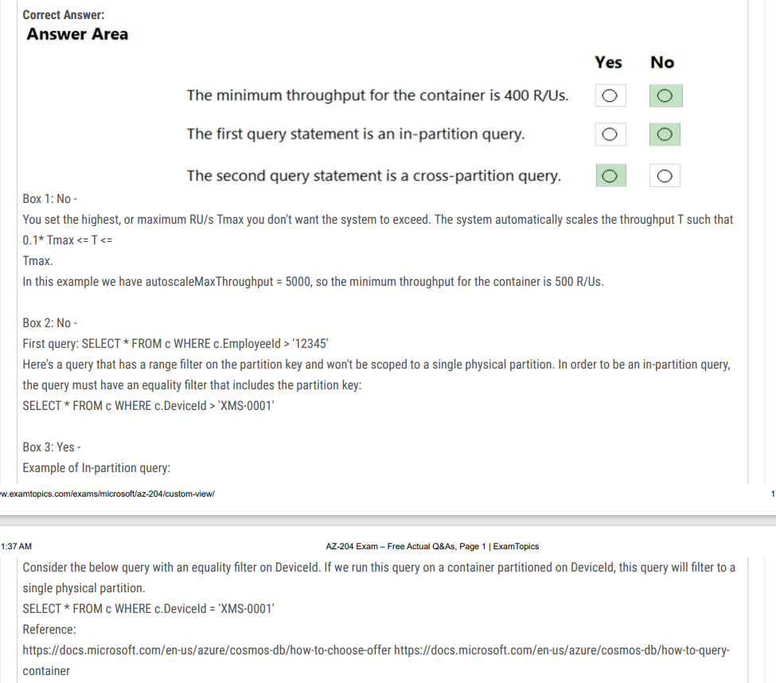

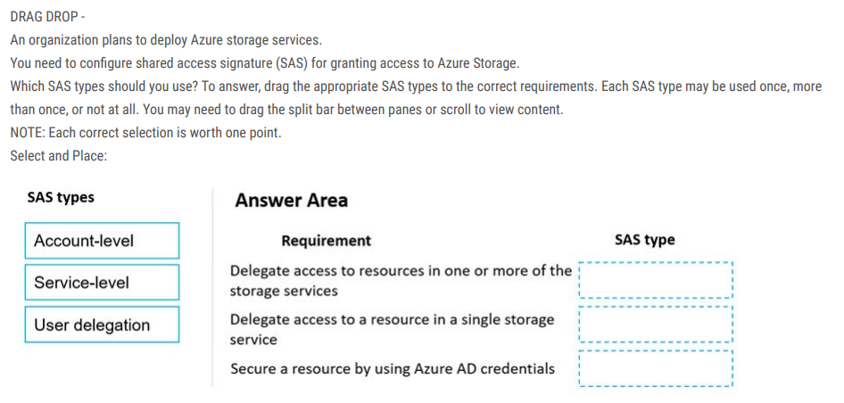

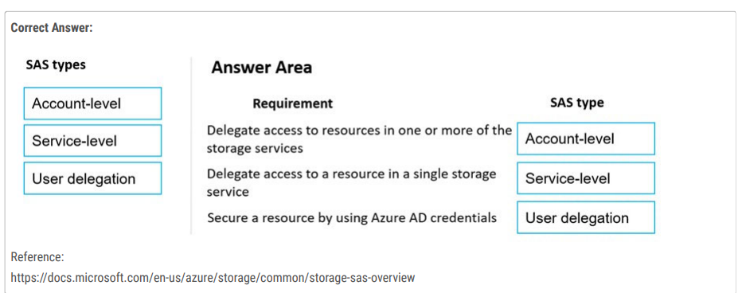

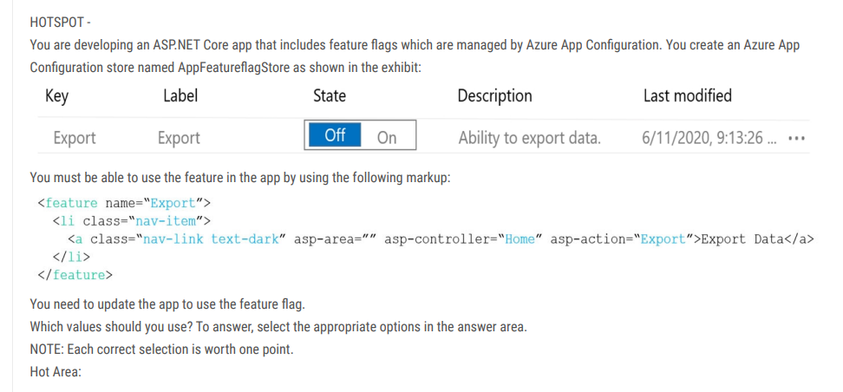

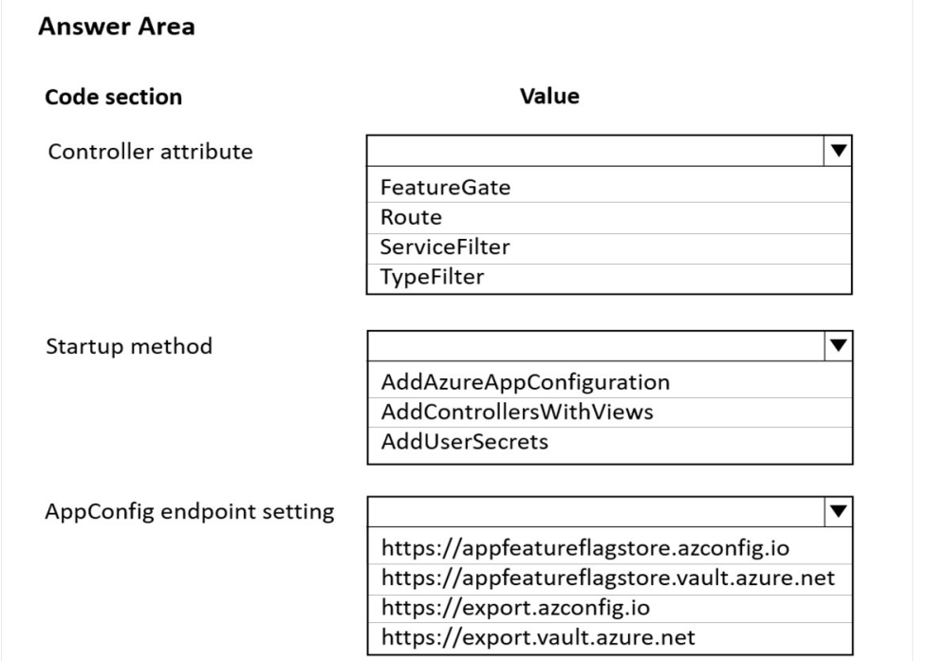

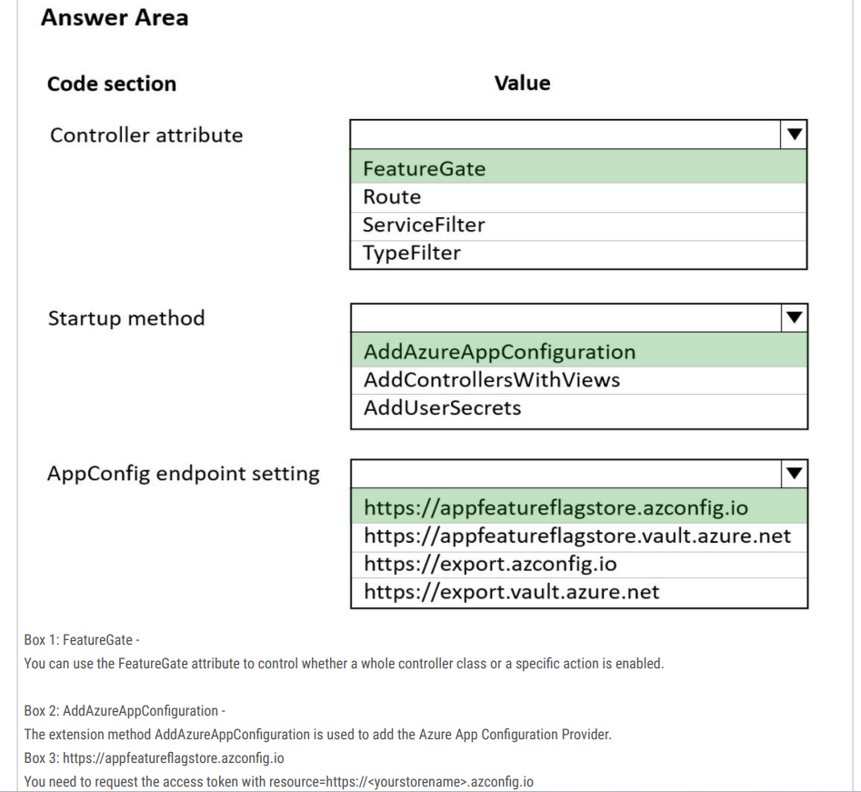

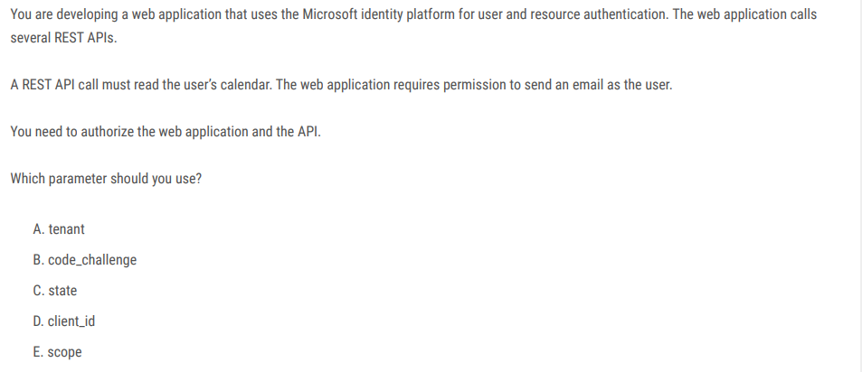

Correct Answer: E

